A Level Science Practical Endorsement

A Level Biology, Chemistry & Physics Science Practical Endorsement

Oxford College of Education working with UK multiple exam centre to help our student.
Our associate partners have been approved by the JCQ to carry out the 12 Science Practical’s for the A Level CPAC’s (Common Practical Assessment Criteria).
(Biology, Chemistry and Physics) for the following Awarding Organisations – Pearson, OCR, Eduqas
and AQA.

Examination boards state that candidates are expected to have completed 12 practicals’ for the
practical endorsement in addition to the three written examination papers. The practical’s do not
count towards the final grade but the content of paper 3 is based on them. The lab familiarisation, held on Day 1 is primarily for candidates to learn how to handle equipment.
safely and to know what is expected from them. It will also provide an ideal opportunity to speak to
the teachers and learn about the requirements of CPAC.

CPAC (Common Practical Assessment Criteria)
Number of Practical’s Assessment : 12
Assessment Length : 4 days
Practical days: Monday : Friday

FEES
- Harrow - London: £ 1750 (per A Level Subject)
- South Bank -London: £ 1750 (per A Level Subject)
- Bolton: £ 1750 (per A Level Subject)
- Taunton (Somerset, Southwest England): £ 1750 (per A Level Subject)
- Coventry: £ 1750

Day 1 will also include the first practical.
Day 2 will cover three practicals.
Day3 & 4 will cover four practicals each.

Class sizes will be limited to ensure a positive CPAC experience. Please be aware that at least 15% of
the marks for an A-level Science qualification require the assessment of practical skills.

Consequently, we ask that candidates who wish to attend CPAC sessions should be adequately prepared for the intensity of the workload required to meet the stipulated expectations of the Awarding Organisations. Each candidate is expected to keep an appropriate record of their practical work, including their assessed practical activities, and show that they can apply the knowledge already embedded from completing the necessary work required in the course specifications. Candidates should be aware that work outside of the four CPAC sessions will also be required.

How to Book

To register for our CPAC’s you will need to complete our application form and return it along with
photo ID (a recent passport size/style photo will suffice). Your place will only be assigned once full
payment is received. Once your application has been received, we will raise an invoice which can be paid by bank transfer, cash, or card payment. Please state at the time of returning the application form your intended payment method. We can send you a link to pay if required.

PLEASE NOTE:
- Wear warm clothes, lots of layers, we will have some windows open to maximise the
- ventilation in the room which is a key factor in minimising the risk of infection.
- Bring your own lab coat if you want, this is not classed as PPE equipment and must not be
- shared with other candidates.
- Bring your own laptop – electronic work.
- Bring your own pencil case with stationery.
- If you are bringing your own antibacterial hand sanitiser/wipes, please ensure it is non-alcoholic (alcoholic hand gel is flammable and could ignite whilst using the Bunsen burners).

They will provide:
- Protective eyewear
- Nitrile gloves
- Lab books and basic stationery i.e.; graph paper and tracing paper

Harrow London- Scheduled CPAC Dates Available

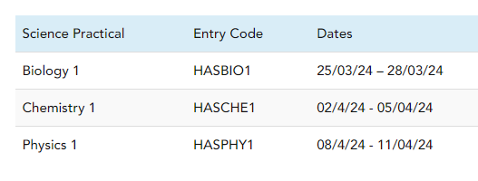

Coventry Science Lab

Scheduled CPAC Dates Available
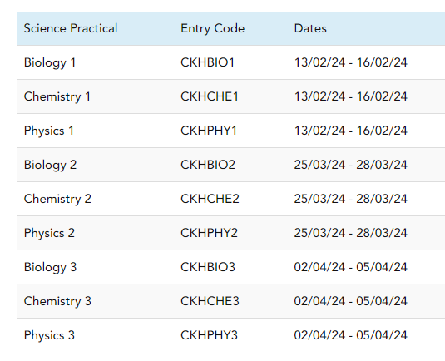

Bolton

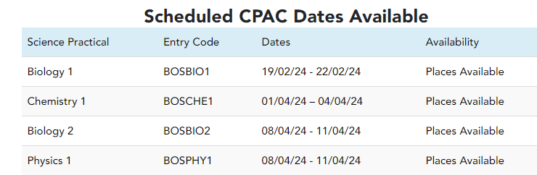

South Bank UTC (London) Science Lab

Scheduled CPAC Dates Available
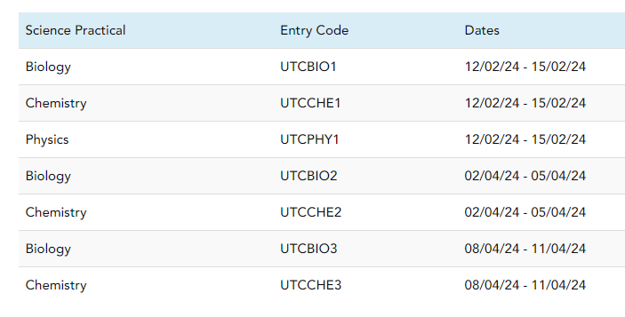
Taunton (King’s College)- TA1 3LA

Scheduled CPAC Dates Available

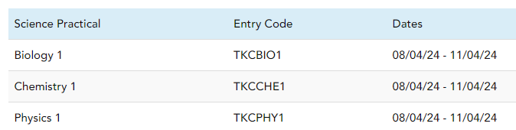

Book now:

